Topic 2: Mechanics

0.2 Specification notice:
In order to develop their practical skills, students should be encouraged to carry out a range of practical experiments related to this topic. Possible experiments include strobe photography or the use of a video camera to analyse projectile motion, determine the centre of gravity of an irregular rod, investigate the conservation of momentum using light gates and air track.
Mathematical skills that could be developed in this topic include plotting two variables from experimental data, calculating rate of change from a graph showing a linear relationship, drawing and using the slope of a tangent to a curve as a measure of rate of change, distinguishing between instantaneous rate of change and average rate of change and identifying uncertainties in measurements, using simple techniques to determine uncertainty when data are combined, using angles in regular 2D and 3D structures with force diagrams and using sin, cos and tan in physical problems.
This topic may be studied using applications that relate to mechanics, for example, sports.

2.9 - be able to use the equations for uniformly accelerated motion in one dimension (SUVAT)

What are the assumptions we make when solving problems using the SUVAT equations? | Must be constant acceleration and travelling in a straight line?
What are the 5 SUVAT equations for an object moving at constant acceleration? | - s=vt-0.5at²  - v=u+at  - s=0.5(u+v)t  - s=ut+0.5at²  - v²=u²+2as

2.10 - be able to draw and interpret displacement-time, velocity-time and acceleration-time graphs

What does a straight line represent on a displacement-time graph?  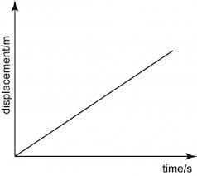 | Constant velocity
What does a curved slope represent on a displacement-time graph?  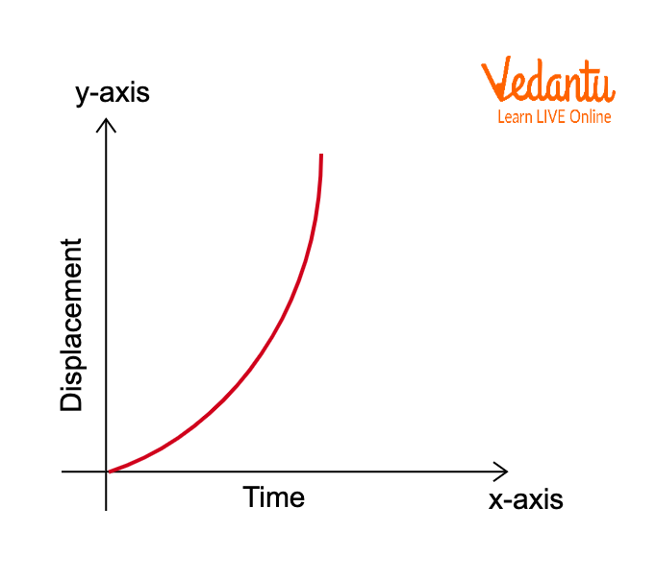 | Acceleration
What does a horizontal line represent on a displacement-time graph?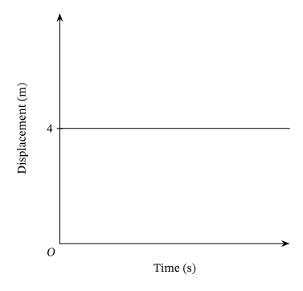 | Stationary (State of rest)
What does the area under the curve mean in a displacement-time graph? | Its meaningless
What does a straight line represent on a velocity-time graph?  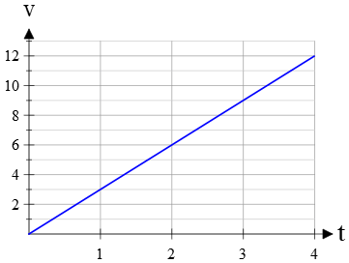 | Uniform acceleration
What does a curved line represent on a velocity-time graph?  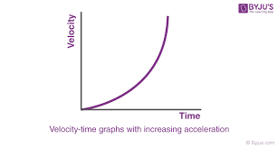 | Non uniform acceleration
What does a negative slope represent on a velocity-time graph?  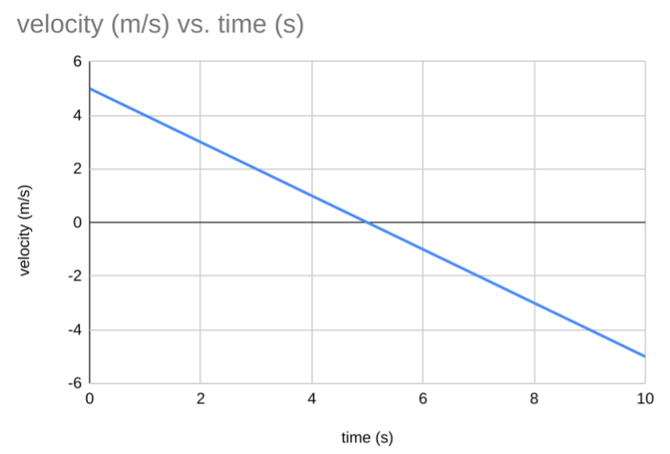 | Increase in velocity
What does a horizontal line represent on a velocity-time graph?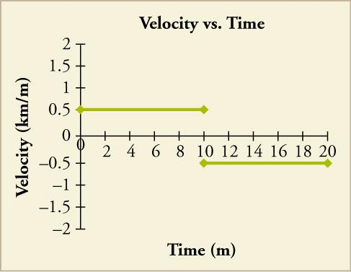 | Constant velocity
What does the area under the curve represent on a velocity-time graph? | Displacement (or distance travelled)
What does a horizontal line represent on an acceleration-time graph?  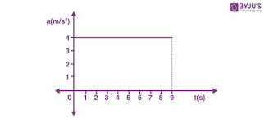 | Constant acceleration
What does the area under the curve represent on an acceleration-time graph? | Change in velocity
What does the steepness of the slope mean in an acceleration-time graph?  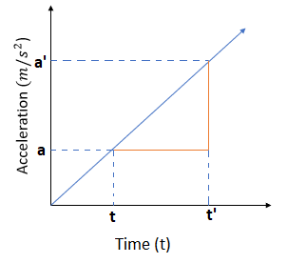 | Its meaningless
Sketch the velocity,displacement and acceleration time graph of a bouncing ball with the ground being the origin and it starting in the air | 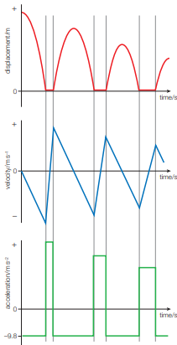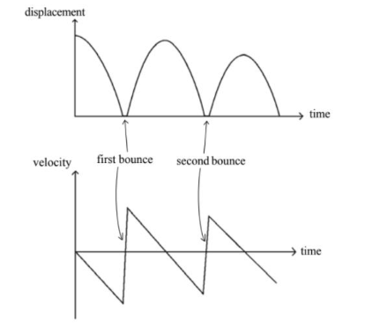

2.11 - know the physical quantities derived from the slopes and areas of displacement-time, velocity-time and acceleration-time graphs, including cases of non-uniform acceleration and understand how to use the quantities
What does the gradient of a displacement-time graph represent? | Velocity
What does the gradient of a velocity-time graph represent? | Acceleration
What is the average speed? | The total distance divided by the total time
What is the instantaneous speed? | The speed at a particular moment in time
What is velocity? | Speed in a given direction
What is acceleration? | The rate of change of velocity

2.12 - understand scalar and vector quantities and know examples of each type of quantity and recognise vector notation
What are 10 examples of scalar quantities? (It doesn’t have to be in order) | Distance, speed, mass, time, energy, volume, density, pressure, electric charge, temperature
What are 5 examples of vector quantities? (It doesn’t have to be in order) | Displacement, velocity, acceleration, force, momentum

2.13 - be able to resolve a vector into two components at right angles to each other by drawing and by calculation
What does the arrowhead & length represent by a vector arrow? | - The arrowhead indicates the direction of the vector  - The length of the arrow represents the magnitude
When is an object in equilibrium? | When there is no resultant force and moments balance  Thus when > 3 forces act on a body in equilibrium the resultant of all but one will be equal and opposite to the last. Similarly, the sum horizontal and vertical components of all forces is 0

2.14 - be able to find the resultant of two coplanar vectors at any angle to each other by drawing, and at right angles to each other by calculation
How is the resultant force calculated? | By creating a right angle triangle with forces tip to tail and using Pythagoras theorem

2.15 - understand how to make use of the independence of vertical and horizontal motion of a projectile moving freely under gravity

2.16 - be able to draw and interpret free-body force diagrams to represent forces on a particle or on an extended but rigid body
What are the 3 rules of free-body diagrams? | - Force vectors must originate from an object  - Forces must only act on one body  - Forces must be named

2.17 - be able to use the equation ∑F = ma, and understand how to use this equation in situations where m is constant (Newton’s second law of motion), including Newton’s first law of motion where a = 0, objects at rest or travelling at constant velocity. Use of the term terminal velocity is expected
What is Newton’s First law of Motion (Law of inertia)? | An object remains at rest or with a constant velocity unless acted upon by a resultant force  (In terms of momentum: The momentum of a body remains constant unless a net force acts on the body)  VELOCITY is key as an object moving in a circle experiences a centripetal and is thus accelerating. Let’s say you had a cup on a table, although it looks stationary,considering the Earth/Table perspective, it isn’t as it’s weight is slightly greater than the normal force as it’s experiencing a centripetal force due to the Earth’s rotation. However, we assume they are the same
What is Newton’s Second law of motion? | The resultant force is directly proportional to the acceleration an object with constant mass  (In terms of momentum: The resultant force is proportional to the rate of change of momentum and acts in the same direction as the change in momentum)  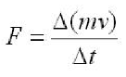  F=ma is a special case where mass is constant. This cannot be used for a rocket.  Remember that the change in momentum has to be constant. E.g., going from 5 kgms⁻¹ to 0 kgms⁻¹ exerts some force whose size is dependent on the time in which this change occurs. Thus cushions work better than harder surfaces such as steel.
When is an object in equilibrium? | When there is no resultant force and moments balance  Thus when > 3 forces act on a body in equilibrium the resultant of all but one will be equal and opposite to the last. Similarly, the sum horizontal and vertical components of all forces is 0
Describe the stages of a skydiver (He) jumping out a plane? | - He initially accelerates at 9.81ms⁻²  - Air resistance increases as he falls faster until he reaches terminal velocity  - When the parachute opens the force of air resistance increases drastically causing deceleration  - Air resistance balances his weight again when he reaches terminal velocity again  His weight remains constant through his dive
Explain why in a vacuum all objects will fall at the same acceleration? | The only force acting on the object is it weight as W=mg and F=ma and so ma=mg so a=g where g is constant

2.18 - be able to use the equations for gravitational field strength g=F/m and weight. W = mg

2.19 - CORE PRACTICAL 1: Determine the acceleration of a freely falling object.
Explain how to measure the rate of acceleration due to gravity (g) by free fall practically in the lab (6)? | - Use a release mechanism to drop a ball that starts a timer on release  - Place a trap door below the ball so that when the ball strikes the door it breaks a circuit and stop the timer  - Measure the distance between the trap door and the release mechanism with a ruler  - Repeat this at 20cm intervals from 0.20m to 2.00m  - Plot a graph of s (height) on the y-axis and t² on the x-axis  - Gradient = 0.5xg, as s=ut+0.5at² and g=a
Draw the apparatus on CPAC1 | 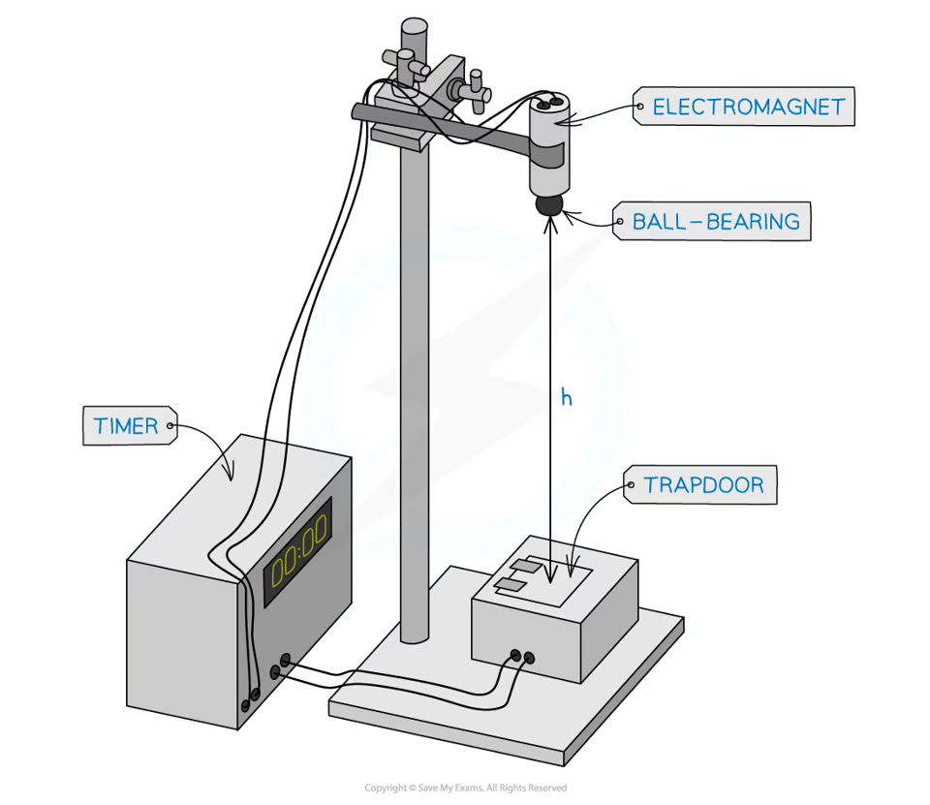  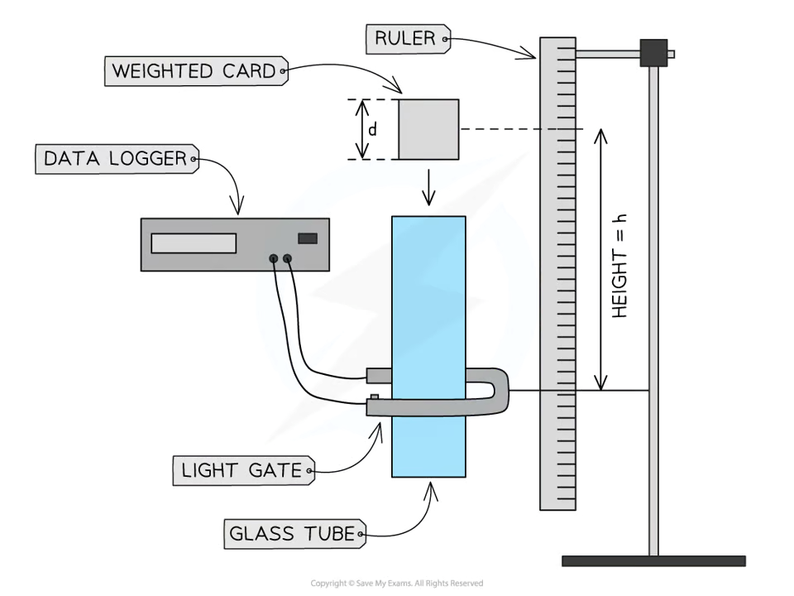

2.20 - know and understand Newton’s third law of motion and know the properties of pairs of forces in an interaction between two bodies
What is Newton’s Third Law of Motion? | Whenever two bodies interact, the forces they exert on each other are equal in magnitude act in opposite directions are of the same type acting along the same line of action  (In terms of momentum: Colliding bodies exert equal and opposite forces on each other so total momentum is unchanged)  This is a result of electrostatic repulsion between electrons. When you “touch” stuff, you’re not actually touching it. Your hand is slightly hovering above it

2.21 - understand that momentum is defined as p = mv
Define momentum? | The product of mass and velocity of an object (P=mv)

2.22 - know the principle of conservation of linear momentum, understand how to relate this to Newton’s laws of motion and understand how to apply this to problems in one dimension
What is the principle of conservation of momentum? | Total momentum before collision equals the total momentum after the collision unless an external force acts  External forces include friction. They affect the total momentum as they can reduce the velocity of an object
What is the notation to write when dealing with perfectly inelastic (they stick after) momentum questions ? | ⅀P_{before} = (M₁ x V₁) + (M₂ x V₂)  Identify the direction of motion and if there are any objects colliding with a negative momentum  ⅀P_{before} = ⅀P_{after} due to the cons of momentum  ⅀P_{after} = (M₁ + M₂) x (V₁ + V₂)

2.23 - be able to use the equation for the moment of a force, moment of force = Fx where x is the perpendicular distance between the line of action of the force and the axis of rotation
What is the principle of moments? | For a system to be in equilibrium the sum of the clockwise moments equals the sum of the anticlockwise moments
What is a moment defined as? | A force multiplied by the perpendicular distance between the pivot and the line of action of the force (M = F x ⟂d)  In essence, we’re looking at the turning effect of a force. When we take moments about a point, we can ignore the force acting at the point. So never pick a point where you’d have to consider all distances and forces
What is the notation to write when dealing with equilibrium moments questions (generally)? | ⅀↷M = F x ⟂d  ⅀↷M = ⅀↶M  ⅀↶M = F x ⟂d
What is the SI unit for a moment? | Nm or Ncm depending on the units given for the distance

2.24 - be able to use the concept of centre of gravity of an extended body and apply the principle of moments to an extended body in equilibrium
What is centre of mass? And centre of Gravity? | - Centre of mass is the point where all the mass seems to be concentrated  - Centre of gravity is the point where all the weight seems to be concentrated  In a uniform gravitational field, both are in the same place
How can you find the centre of mass of an object? | - Freely suspend an irregular shape from a clamp  - Dangle a plump line from the point of suspension and wait for the object to come to rest  - Draw a line following the string of the plumb line  - Repeat steps 1 - 3 for another point  The centre of mass is where both lines intersect
When will an object rotate and topple (with an example)? | - It rotates when there is a resultant moment acting on it  - It topples when the centre of mass outside the base  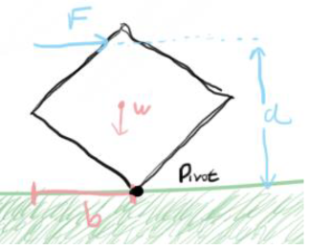

2.25 - be able to use the equation for work ∆W = F∆s, including calculations when the force is not along the line of motion
What is work done | The force multiplied by the displacement in the direction of the force

2.26 - be able to use the equation KE = 1/2mv² = for the kinetic energy of a body
How to calculate velocity from an object's height? | - 0.5mv²=E_{k}  - mgh=E_{p}  - E_{p}=E_{k}  - 0.5mv²=mgh  - 0.5v²=gh  - v=gh

2.27 - be able to use the equation ∆Egrav = mg∆h for the difference in gravitational potential energy near the Earth’s surface

2.28 - know, and understand how to apply, the principle of conservation of energy including use of work done, gravitational potential energy and kinetic energy
What is work? | The energy transferred
What is the principle of the conservation of energy | Energy cannot be created or destroyed only transferred from one store to another
How is mechanical power related to force and velocity | - W=Fs  - P=W/t  - P=Fs/t  - P=Fv

2.29 - be able to use the equations relating power, time and energy transferred or work done P=E/t and P=W/t
What is mechanical power? | The rate of energy transfer
What is power using time and energy transferred/ work done? | - P=E/t  - P=W/t

2.30 - be able to use the equations efficiency = useful energy output / total energy input and efficiency = useful power output / total power input
What is the efficiency equation with energy? | Efficiency = Useful energy output/total energy input x 100% E=UEO/TEI x 100%
What is the efficiency equation with power? | Efficiency = Useful power output/total power input x 100% E=UPO/TPI x 100%

